Kohl Johnson

Family of Operating Systems Activity

06/08/2024

# Table of Commands

|  |  |
| --- | --- |
| **Command** | **What it does** |
| whoami | Prints out the active user |
| users | Prints out all the users |
| ls | Prints the names of files in current directory |
| ls -r | Prints the names of files in reverse order, in current directory |
| ls -l | Prints detailed stats about every file in current directory |
| ls -lh | Same as above, but makes it a tad bit more human readable |
| chmod o-rwx filename | Removes read, write, and execution permissions from said file |
| chmod o+rwx filename | Adds read, write, and execution permissions from said file |
| Printenv VARNAME | Prints out the value of the supplied environment variable, leave blank to get all of them printed out |
| grep - - color “test” test.txt | Searches for “test” in test.txt then shows where the string is at within the file |
| sort test.txt | Outputs the contents of test.txt line by line but in alphabetical order |
| grep - - color “test” * | sort * | Searches for “test” in all files within the current working directory and then prints it out in alphabetical order, no idea how this was useful, but it printed some wack stuff. |
| sudo -V | Prints the current version of sudo along with its extensions(?) |
| man man | Shows the entire manual |
| man ARTICLE_NAME | Shows the manual entry for the supplied article |

# Whoami Screenshot

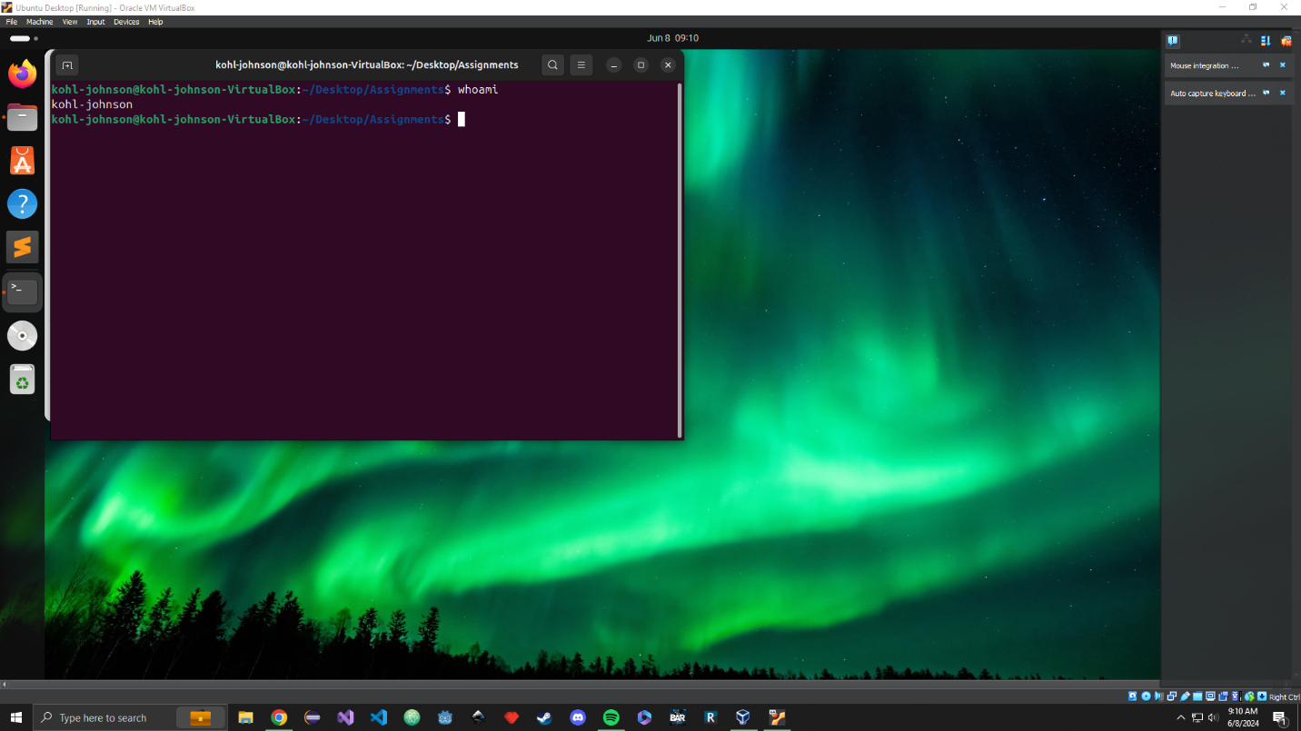

# Users Screenshot

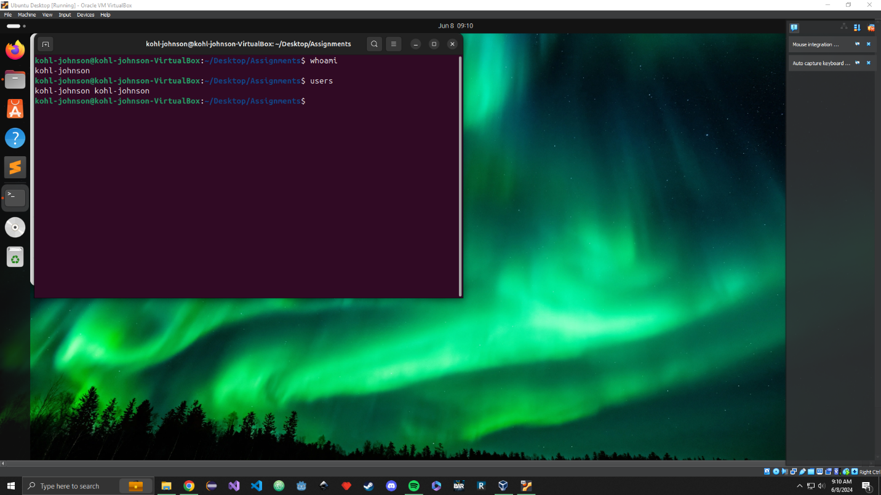

# Ls Screenshot

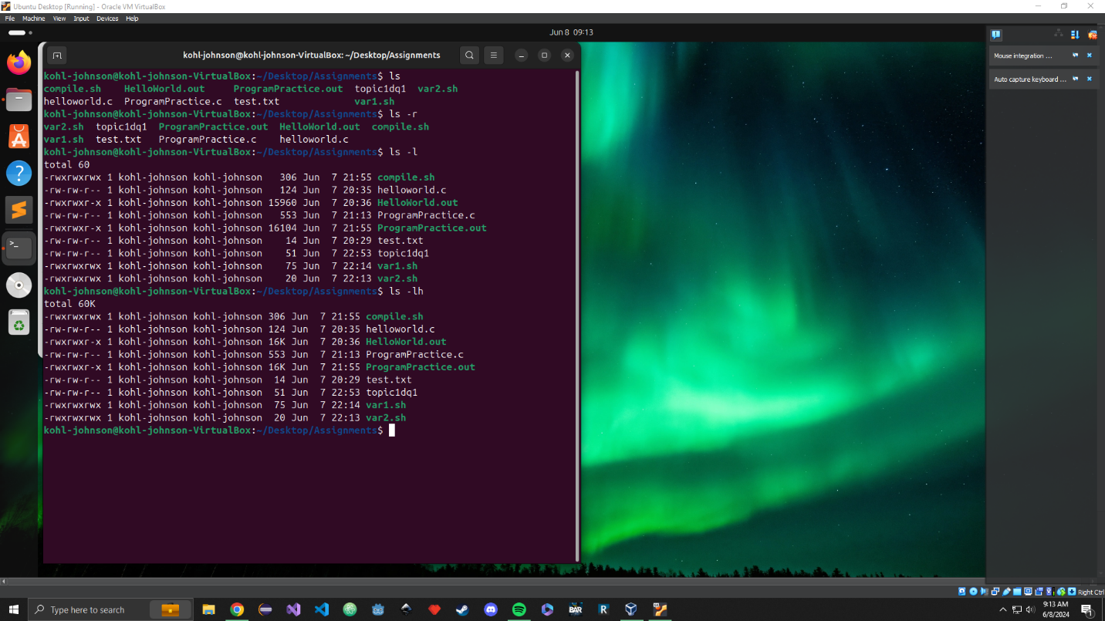

# Chmod Screenshot

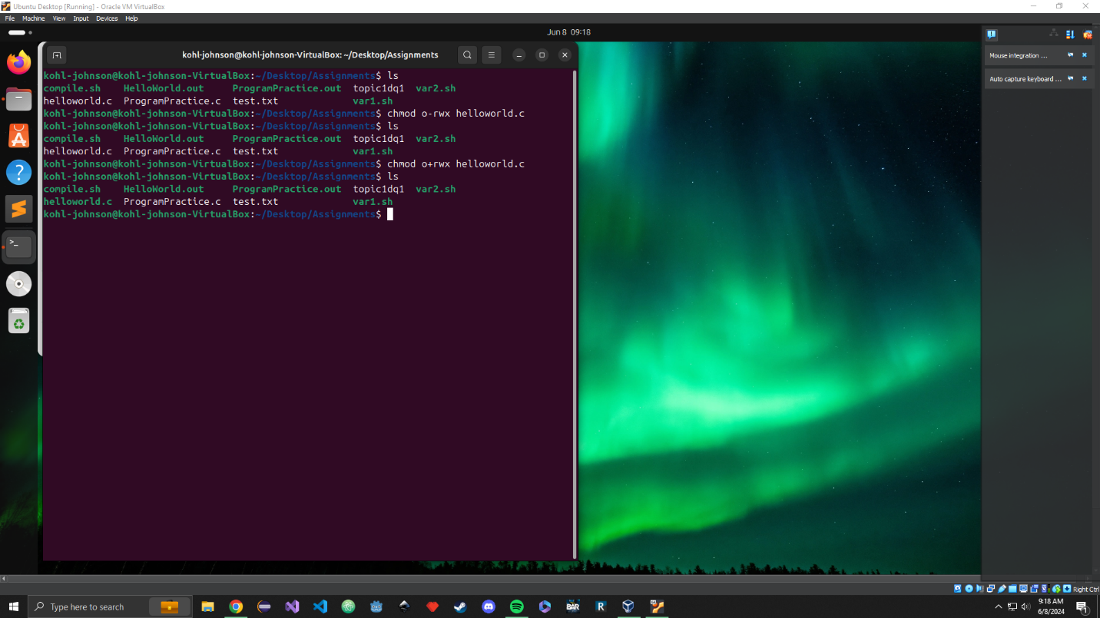

# Printenv Screenshot

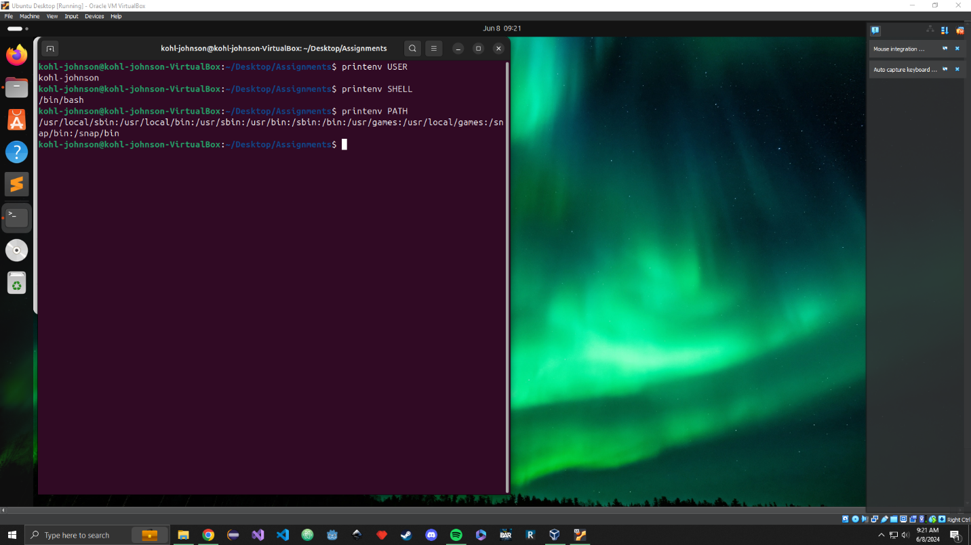

# Grep Screenshot

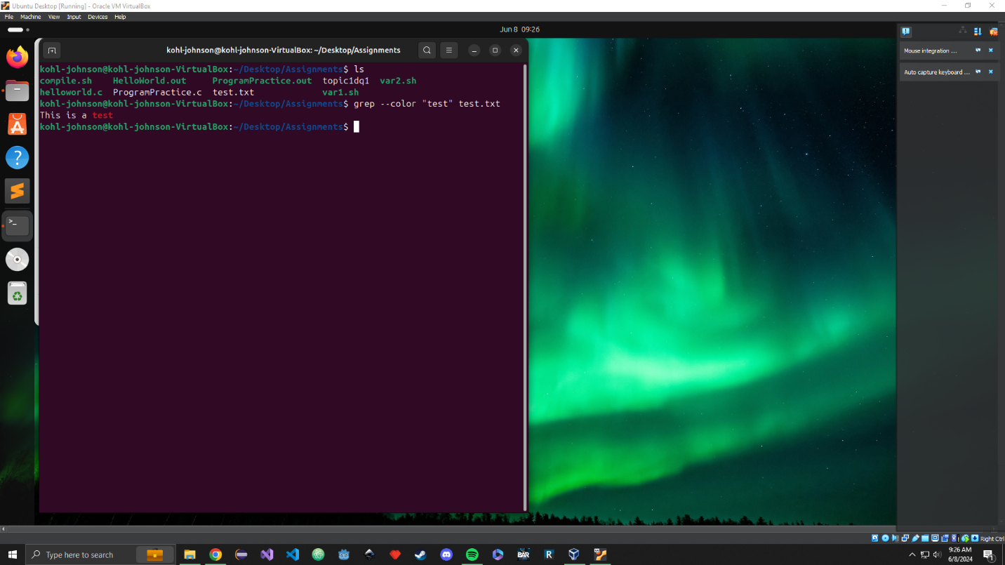

# Sort, grep, and pipeline Screenshot A

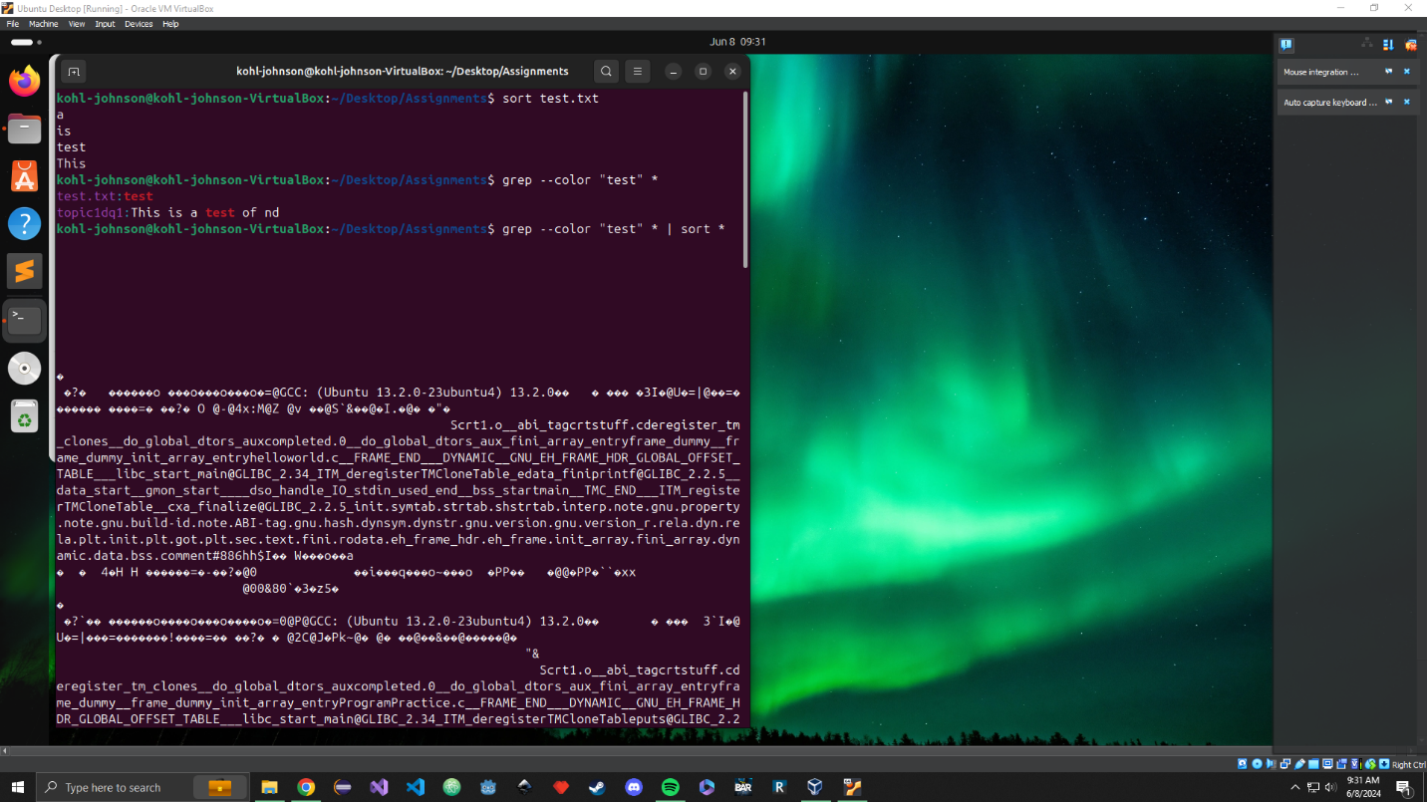

# Screenshot B

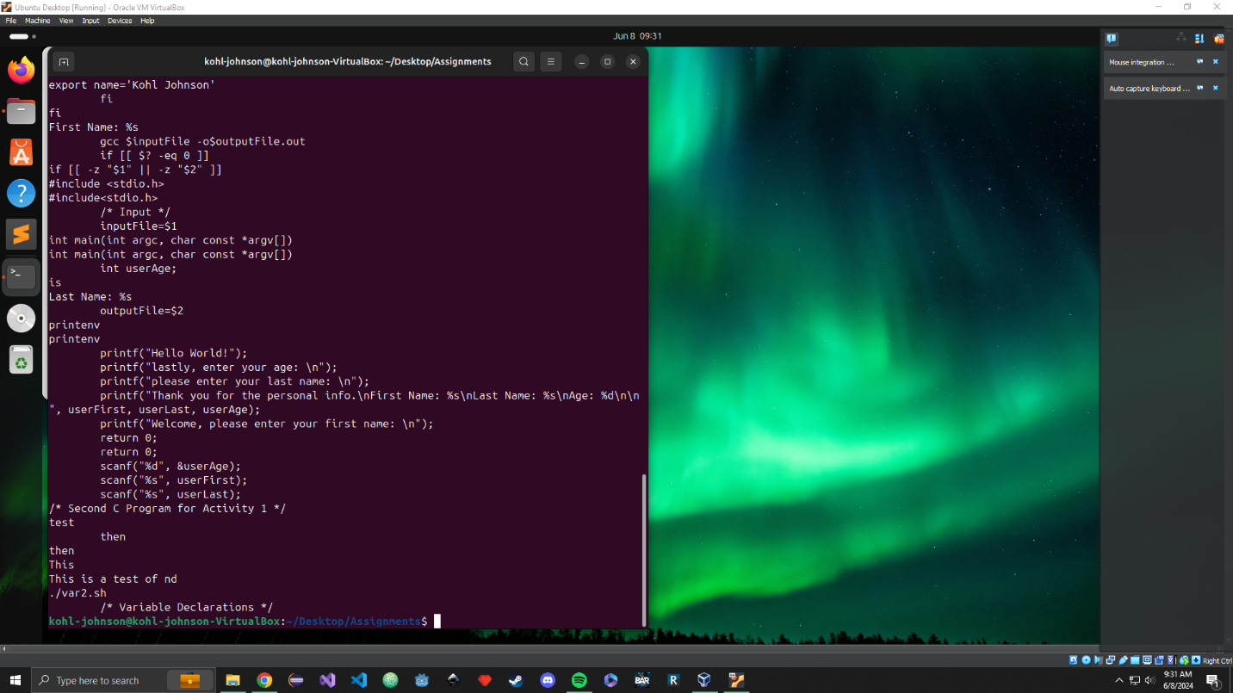

# Sudo Screenshot

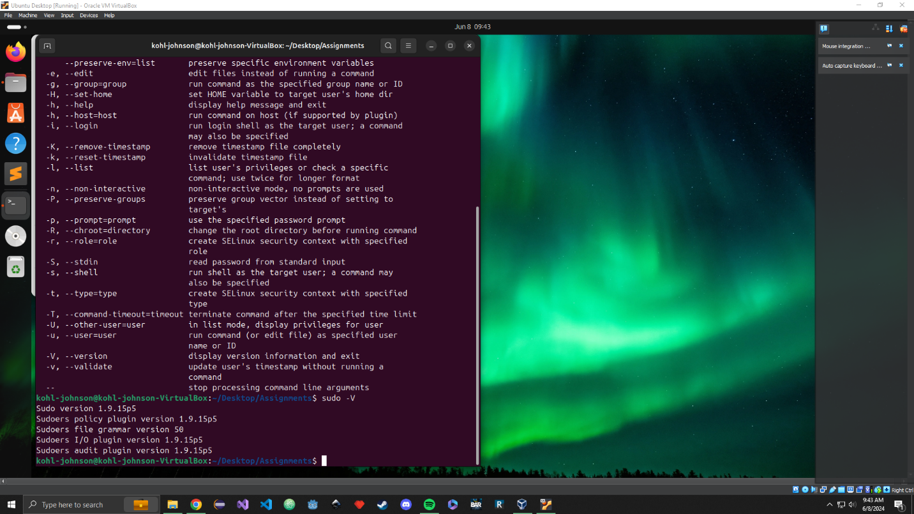

# Man Screenshot

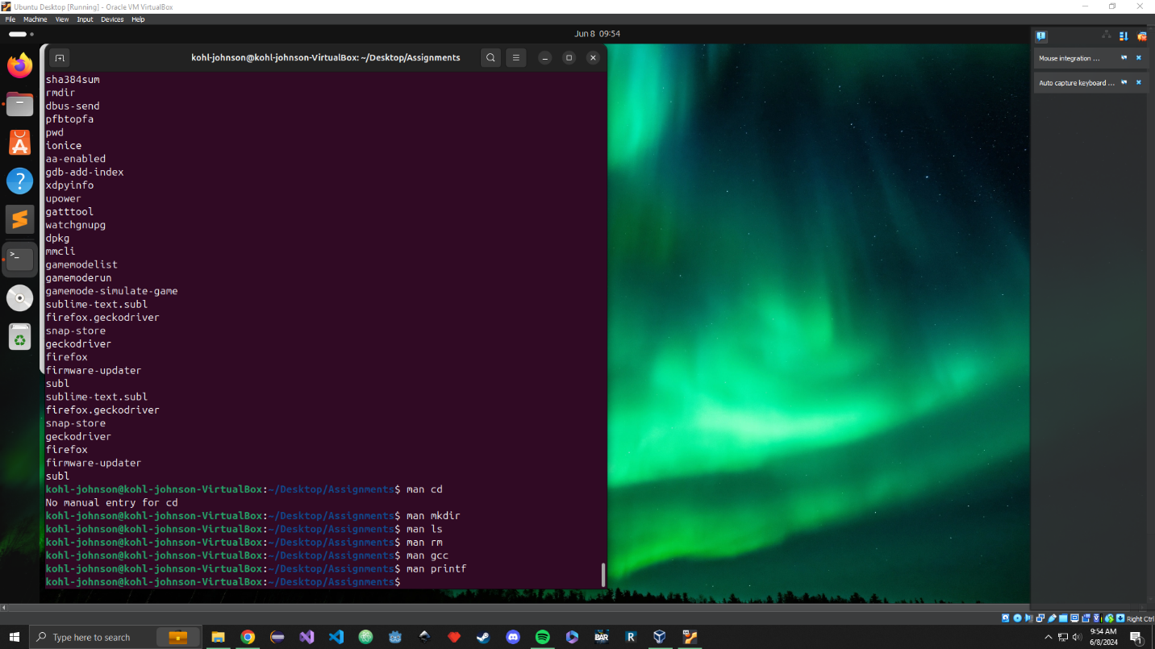

# Shell Script Screenshot

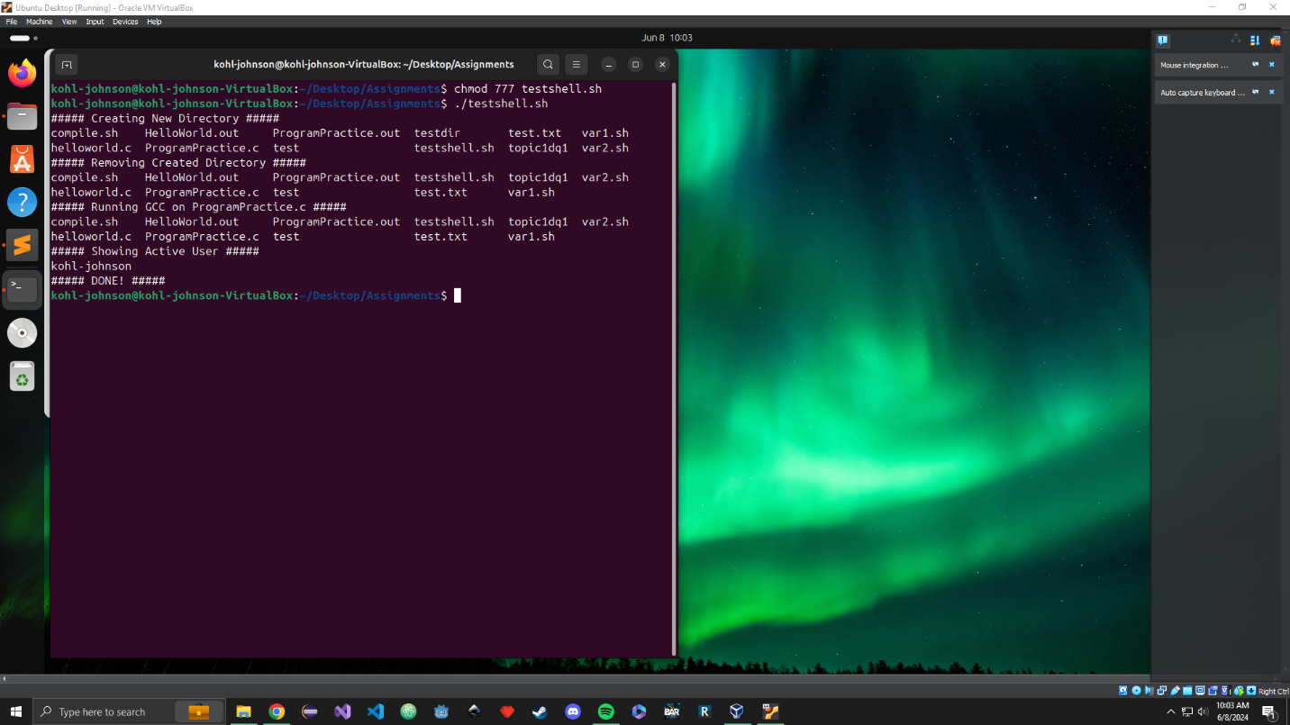

# Sources/References

<https://www.digitalocean.com/community/tutorials/ls-command-in-linux-unix>

<https://www.pluralsight.com/blog/it-ops/linux-file-permissions>

<https://www.digitalocean.com/community/tutorials/grep-command-in-linux-unix>

<https://www.javatpoint.com/linux-sudo>

<https://www.geeksforgeeks.org/man-command-in-linux-with-examples/>